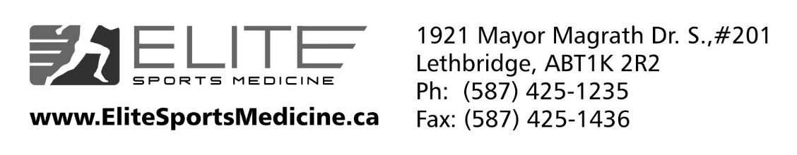

Elite Sports Medicine is a growing, dynamic multi-disciplinary Sports Medicine clinic in Lethbridge, Alberta. We are seeking a full or part-time Primary Care Sports Medicine Physician.

ESM provides 1 Primary Care Sports Medicine physician, 2 Physiotherapists, 2 Chiropractors, and 3 Massage Therapists. All providers share a single EMR. Office administration and billing are provided. We have a large referral base from numerous physicians and physiotherapists throughout Southern Alberta.

Physician roles include treating acute and chronic MSK and sports-related injuries; including acute injuries, chronic overuse injuries, MSK U/S, concussion management, uncomplicated fracture care, and various injection therapies, including Hydrodilatation, Visco-supplementation, Prolotherapy, and PRP. We provide medical care for the WHL Lethbridge Hurricanes hockey club. Assisting with a small panel of Family Medicine patients is also expected.

Potential event coverage includes: WHL Lethbridge Hurricanes, high school football and rugby, Lost Soul ultra-marathon, and other community sporting events.

Qualifications:
- Good standing with the College of Physicians and Surgeons of Alberta
- Fellowship in Primary Care Sports Medicine w/ CASEM Dip. Sport Med, CAC, CAQ, or equivalent
- Preference is given to physicians with experience in Regenerative Injection Therapies (ie: Prolotherapy and PRP) & MSK U/S training
- Ability to work individually and as part of a multi-disciplinary health care team

All interested candidates can contact Trista Green, Office Manager
Email: elitesportsmedclinic@gmail.com
Phone: 587-425-1235

